GLOSSARY
IT 327 PACKET
An Excellence Project by Ed Packer, Fall 2007; expanded by Alcides de Souza, Winter 2011; Expanded by Glenn Werner, Fall 2016

*Page numbers from the course textbook are provided for some of the definitions if you wish to learn more about the topic. Other topics discussed in this document are addressed in the chapters under “Supplementary Material” on the course website.

AC (Alternating Current): Electric current that changes polarity or direction.

ASCII: This acronym stands for American Standard Code for Information Interchange which first came out in 1963. It uses seven bits to represent characters such as the Alphabet, numbers, punctuation, and other symbols. These bits can then be sent using digital communication. Pg. 325.

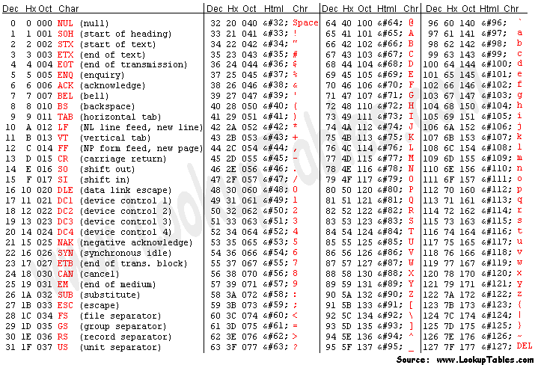

BER (Bit Error Rate): This shows what fraction of the total bits are in error. For example, 1 bit in error in 10,000 bits = 1E-4 BER. Pgs. 357, 373.

Capacitance: The ability to store charge in an arrangement of two plates with a difference of potential between them. Measured in farads (F).

Capacitor: A setup of two conductive plates separated by an insulating material. Depending on the surface area of the plates and the distance between them an amount of charge will be stored.

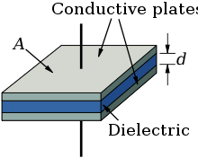
Picture from wikipedia.com
Circuit: A circuit is a specific path from one point to another in a network.

Coaxial Cable: This cable is made by enclosing a central wire with a conducting cylinder on the same axis. Pgs. 194-195.

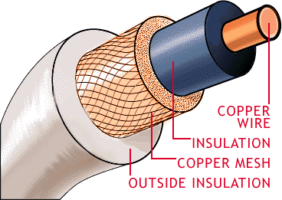
Picture taken from searchnetworking.techtarget.com
Current: The flow or movement of charged particles. Current is measured in amperes (A). One ampere equals one Coulomb of electric charge per second; a Coulomb is 6.24 x 10¹⁸ electrons.

DC (Direct Current): Electric current that does not change direction, or polarity as alternating current does.

Frequency: The number of cycles of a periodic wave (such as a sine wave) that occur in one second. Measured in Hertz (Hz). Pg. 7.

Inductance: a property of electric circuits that induces a voltage that opposes change in the circuit current.

Inductive Reactance: The opposition to ac current resulting from the inductance of a circuit or coil.

Kirchhoff’s current law: Law that states that the sum of the current entering and the sum of the current leaving a junction are equal.

Kirchhoff’s voltage law: Law that states that the sum of the voltage drops around a circuit equals the total voltage provided from the source.

Modulation: The process of modifying a wave so that it can carry information is known as modulation. There are three ways of modulating a wave: changing its amplitude, frequency, or phase. Pgs. 5, 32-33, 74.

Moore’s Law: Intel pioneer Gordon Moore stated that the number of transistors on a chip would double every eighteen months, and that their cost would fall by fifty percent during the same time.

Ohm’s Law: Ohm’s Law states that “current is directly proportional to the applied voltage and inversely proportional to the resistance of the circuit.” (I=V/R)

Parallel circuit: An electrical circuit in which different branches exist, allowing the same amount of voltage across each branch, but different amounts of current.

Peak Value: The value of the peak of a sine wave representing voltage or the largest instantaneous value of voltage. The peak value is equal to ½ the peak-to-peak value, and 1.414 (or √2) times the RMS value.

Potentiometer: A small device that varies the amount of resistance in a circuit by moving an adjustable wiper that slides an electrical contact along a resistive element. Thus a potentiometer allows voltage adjustment.

POTS (Plain Old Telephone Service): The standard telephone service that has been used in homes for years. Cellphones also use POTS once the signal hits the cell tower. Pg. 450.

Power: The rate that electrical energy is used or transferred. Power is measured in Watts (W), which is directly equivalent to joules per second; that is, 1W = 1 Joule/sec.

Resistance: The property of a material that opposes current flow. Resistance is measured in Ohms (Ω)

Resistor: A small electronic component used in circuits to limit the amount of current passing, or to drop a certain amount of voltage. Resistors allow control of amperage and voltage levels in a circuit.

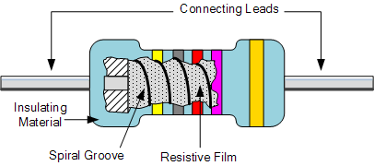
Picture from electronics-tutorials.ws
Resonance: Occurs at a particular frequency in a series LC circuit at which the current has its highest amplitude. It is characterized by the fact that X_{C}=X_{L} (so they cancel each other) and the total impedance (Z) = the resistance of the circuit, and the phase shift =0°.

RMS Value: Root mean square of the peak voltage, or .707 (or 1/√2) times the peak value. Pg. 66.

Series circuits: An electrical circuit in which the components (resistors, capacitors and/or inductors) are arranged in the same branch, so that the same amount of current flows through each, but with different amounts of voltage drop.

SNR (Signal to Noise) Ratio: This compares the level of the target signal to the background noise. It appears in Shannon’s Law and is expressed as S/N in decibels. Pgs. 66-67, 357.

TDR (Time Domain Reflectometry): A method for detecting problems in cables. Problem spots in the cable act as a mirror and reflect some of the energy back towards the transmitter. In order to find the location of these problems, the time is carefully measured from the moment the energy is transmitted until the reflected energy is received, and the distance to the problem is calculated. Pgs. 196-198

Twisted Pair Cable: This type of cable is made by braiding two insulated wires together. It is normally used for connecting computers to the internet. Pgs. 193-194.

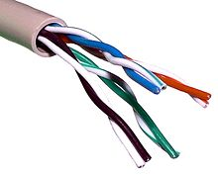
Picture taken from wikipedia.com
Transformer: An arrangement of two or more coils in proximity to each other so that an ac voltage applied to one will induce a voltage in the other(s). Transformers are used to step up or down voltage (and conversely to step current down or up), to provide DC isolation, or to provide impedance matching.

Voltage: The difference of the electrical potential across a circuit. The electrical potential is the force that causes electrons to flow. Voltage is measured in volts (V).

Watt: The SI unit of power. One watt equals 1 Joule per second.

